**AWS-simple Workflow Service**

The following services fall under Application Services section:

* Amazon CloudSearch
* Amazon Simple Queue Services (SQS)
* Amazon Simple Notification Services (SNS)
* Amazon Simple Email Services (SES)
* Amazon SWF

In this chapter, we will discuss Amazon SWF.

**Amazon Simple Workflow Service (SWF)** is a task based API that makes it easy tocoordinate work across distributed application components. It provides a programming model and infrastructure for coordinating distributed components and maintaining their execution state in a reliable way. Using Amazon SWF, we can focus on building the aspects of the application that differentiates it.

A **workflow** is a set of activities that carry out some objective, including logic that coordinates the activities to achieve the desired output.

**Workflow history** consists of complete and consistent record of each event that occurredsince the workflow execution started. It is maintained by SWF.

**How to Use SWF?**



**Step 1**: Sign in to AWS account and select SWF on the Services dashboard.

**Step 2**: Click the Launch Sample Walkthrough button.

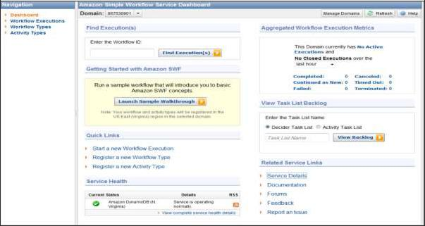

**Step 3**: Run a Sample Workflow window opens. Click the Get Started button.

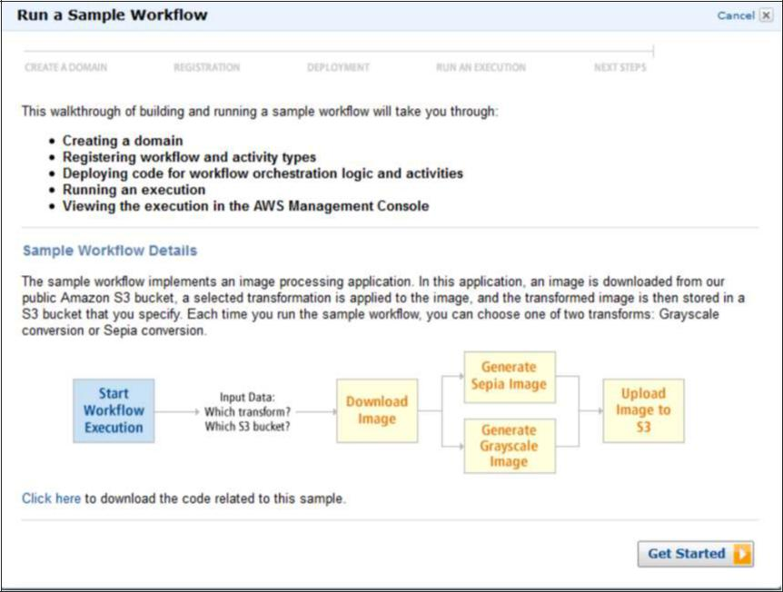

**Step 4**: In the Create Domain section, click the Create a new Domain radio button andthen click the Continue button.

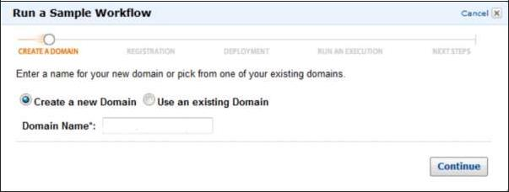

**Step 5**: In Registration section, read the instructions then click the Continue button.

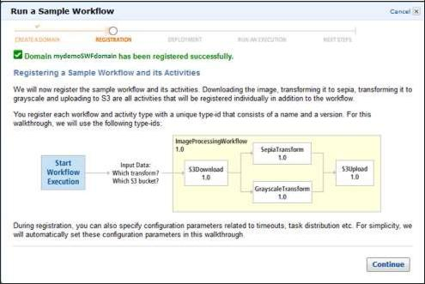

**Step 6**: In the Deployment section, choose the desired option and click the Continuebutton.

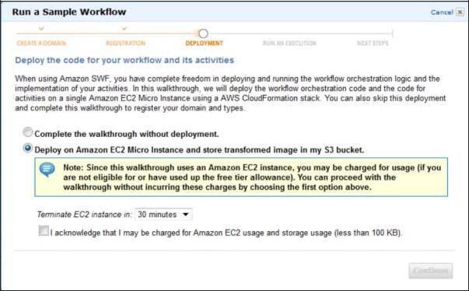

**Step 7**: In the Run an Execution section, choose the desired option and click the Run thisExecution button.

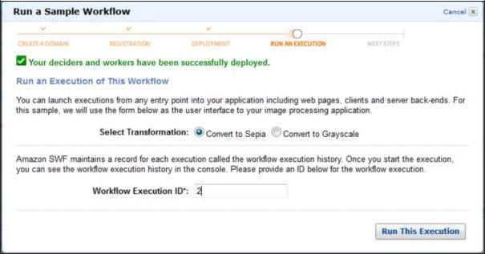

Finally, SWF will be created and will be available in the list.

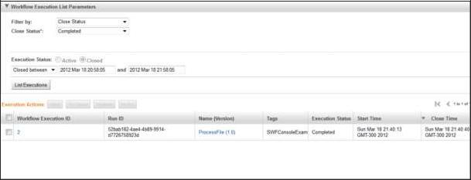

**Benefits of Amazon SWF**



* It enables applications to be stateless, because all information about a workflow execution is stored in its workflow history.
* For each workflow execution, the history provides a record of which activities were scheduled, their current statuses and results. The workflow execution uses this information to determine the next steps.The history provides steps in detail that can be used to monitor running workflow executions and verify completed workflow executions.

**AWS-Work mail**

**Amazon WorkMail** was formerly known as Zocalo. It is a managed email and calendaringservice that runs in Cloud. It provides security controls and is designed to work with your existing PC and Mac-based Outlook clients including the prepackaged Click-to-Run versions. It also works with mobile clients that speak the Exchange ActiveSync protocol.

Its migration tool allows to move mailboxes from on-premises email servers to the service, and works with any device that supports the Microsoft Exchange ActiveSync protocol, such as Apple’s iPad and iPhone, Google Android, and Windows Phone.

**How to Use Amazon WorkMail?**



**Step 1**: Sign in to AWS account and open the Amazon WorkMail console using the followinglink:

<https://console.aws.amazon.com/workmail/>

**Step 2**: Click the Get Started button.

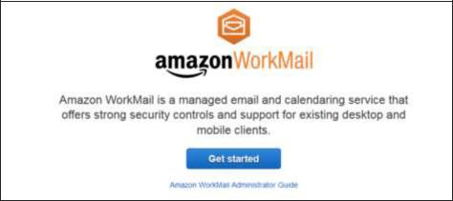

**Step 3**: Select the desired option and choose the Region from the top right side of thenavigation bar**.**

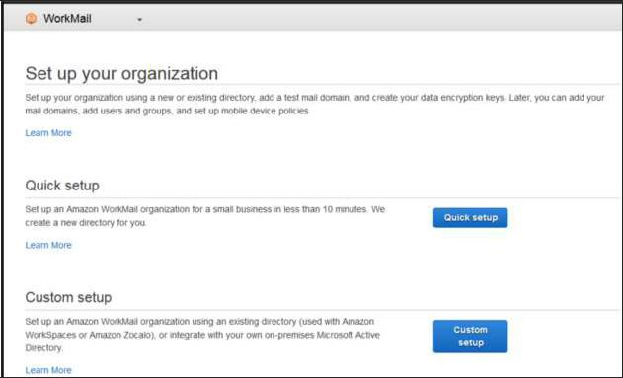

**Step 4**: Fill the required details and proceed to the next step to configure an account.Follow the instructions. Finally, the mailbox will look like as shown in the following screenshot.

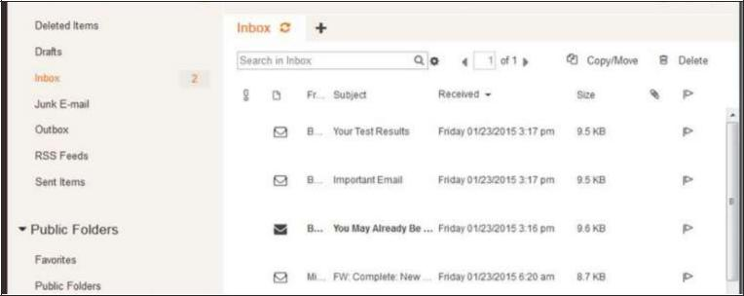

**Features of Amazon WorkMail**



**Secure**: Amazon WorkMail automatically encrypts entire data with the encryption keysusing the AWS Key Management Service.

**Managed**: Amazon WorkMail offers complete control over email and there is no need toworry about installing a software, maintaining and managing hardware. Amazon WorkMail automatically handles all these needs.

**Accessibility**: Amazon WorkMail supports Microsoft Outlook on both Windows and MacOS X. Hence, users can use the existing email client without any additional requirements.

**Availability**: Users can synchronize emails, contacts and calendars with iOS, Android,Windows Phone, etc. using the Microsoft Exchange ActiveSync protocol anywhere.

**Cost-efficient**: Amazon WorkMail charges 4$ per user per month up to 50GB of storage.